a. What are HTTP Status Codes? Categories
Definition
HTTP status codes are standard response codes returned by a server to indicate the result of a client’s request.
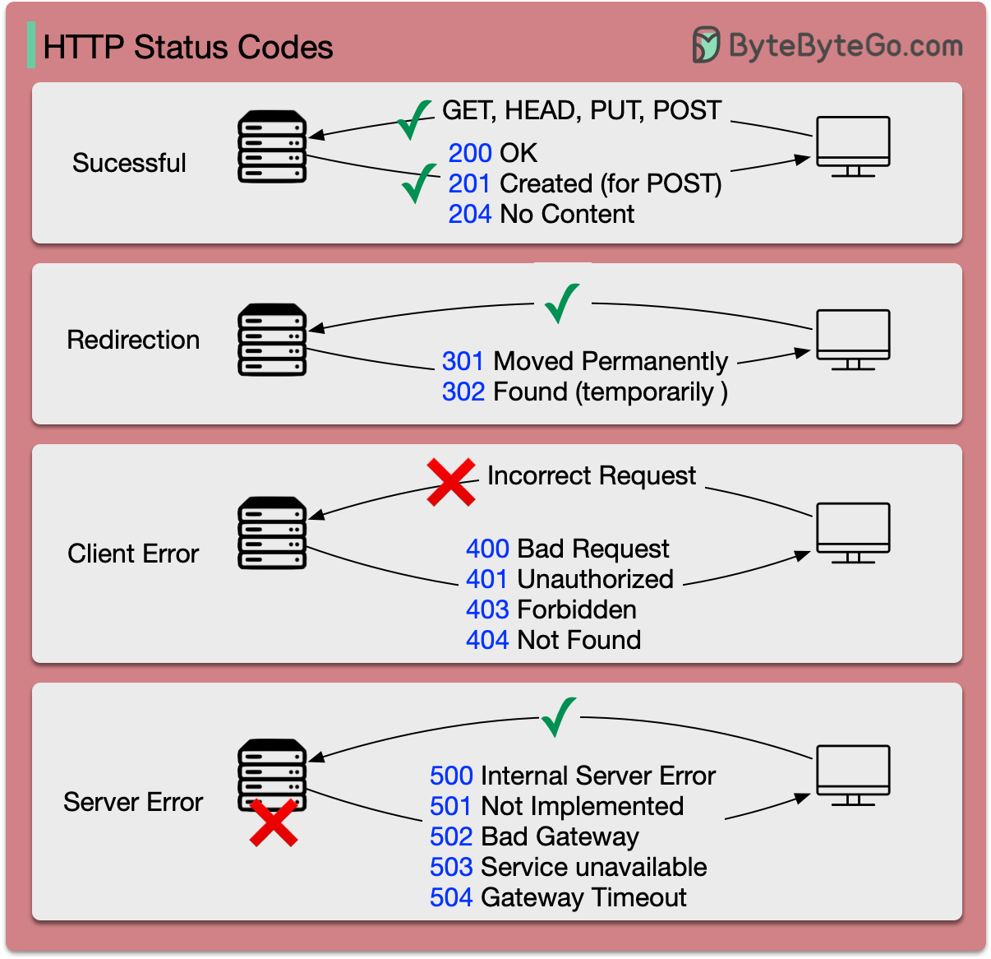
Categories of HTTP Status Codes
Category | Range | Meaning
1xx | 100–199 | Informational (Request received)
2xx | 200–299 | Success (Request successful)
3xx | 300–399 | Redirection (Further action needed)
4xx | 400–499 | Client Error
5xx | 500–599 | Server Error
Examples
- 100 Continue → Request received, continue
- 200 OK → Successful response
- 301 Moved Permanently → Resource moved
- 400 Bad Request → Invalid request
- 404 Not Found → Resource not found
- 500 Internal Server Error → Server failure
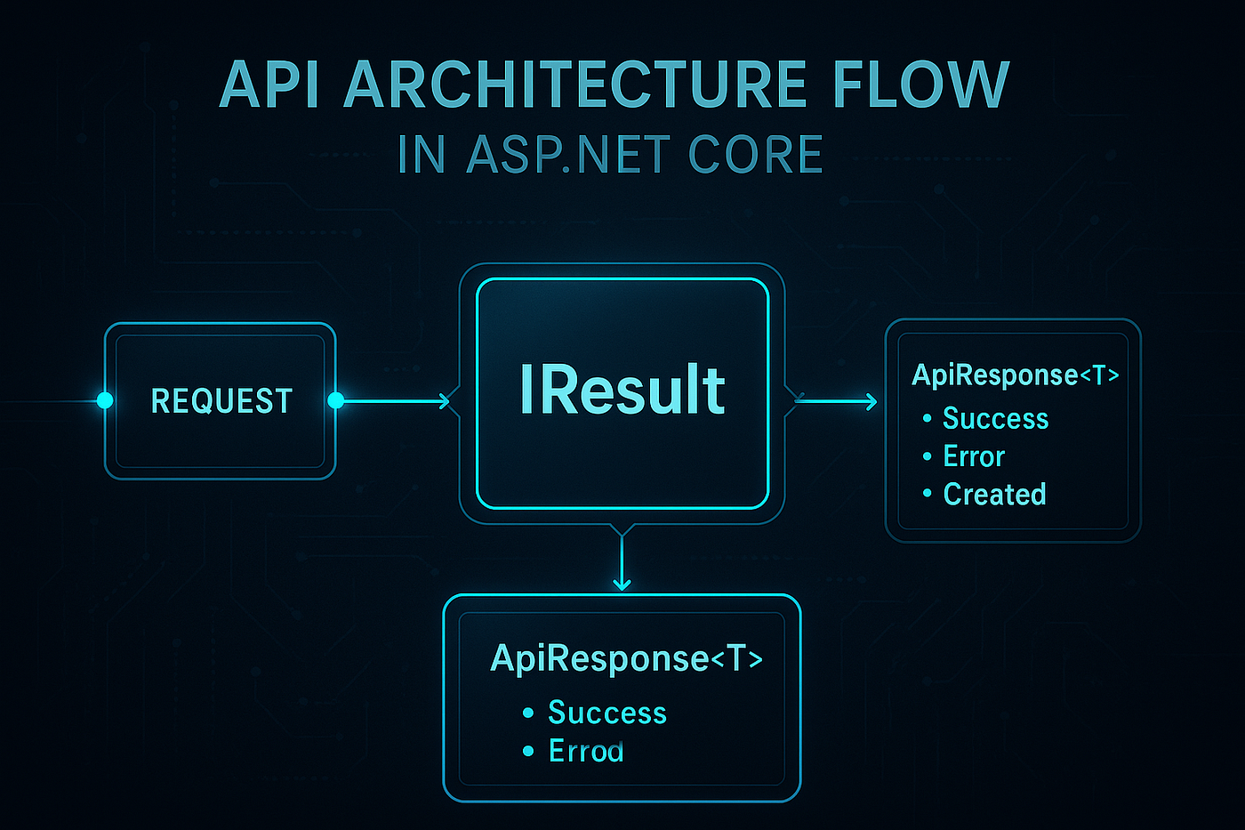
- b. Important HTTP Status Codes with ASP.NET Core Methods
- ASP.NET Core Response Handling

- Table: Status Codes with ASP.NET Core Methods
Status Code | Meaning | ASP.NET Core Method | Result Class
200 | OK | Ok() | OkResult / OkObjectResult
201 | Created | Created() | CreatedResult
204 | No Content | NoContent() | NoContentResult
400 | Bad Request | BadRequest() | BadRequestResult / BadRequestObjectResult
401 | Unauthorized | Unauthorized() | UnauthorizedResult
403 | Forbidden | Forbid() | ForbidResult
404 | Not Found | NotFound() | NotFoundResult
409 | Conflict | Conflict() | ConflictResult
500 | Server Error | StatusCode(500) | StatusCodeResult

Example in ASP.NET Core
[HttpGet("{id}")]
public IActionResult Get(int id)
{
var data = repository.Get(id);
if (data == null)
return NotFound(); // 404
return Ok(data); // 200
}

c. What is Minimal API? (Latest Feature)
Definition
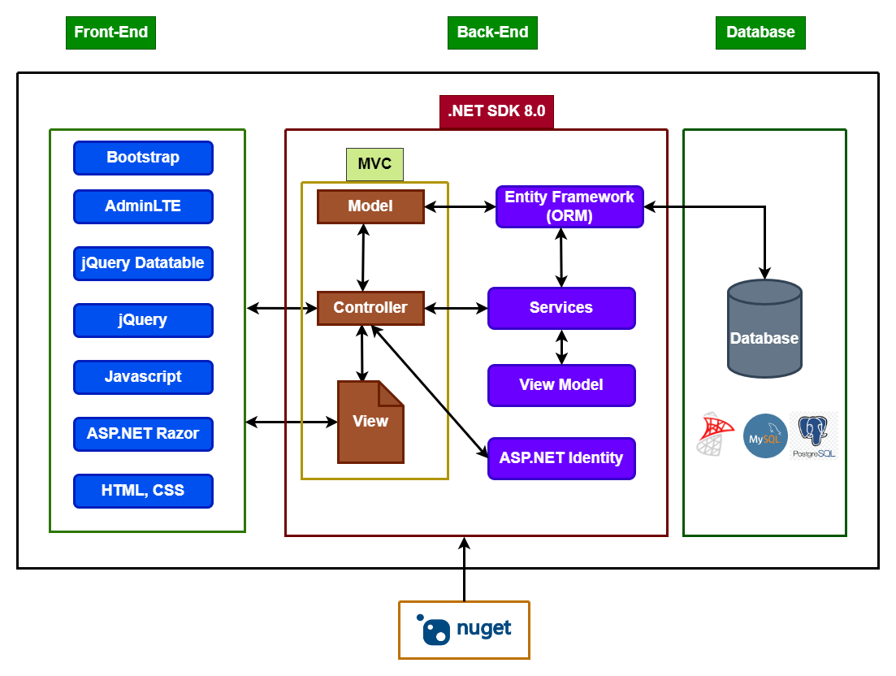
Minimal API is a lightweight way to build APIs in ASP.NET Core with less code, no controllers, and simple configuration.
Key Features
- No Controller & No MVC structure
- Less boilerplate code
- Faster development
- High performance
- Uses Program.cs only
Example Minimal API
var builder = WebApplication.CreateBuilder(args);
var app = builder.Build();
app.MapGet("/", () => "Hello World!");
app.MapGet("/user/{id}", (int id) =>
{
return Results.Ok(new { Id = id, Name = "Vinay" });
});
app.Run();

Comparison: Minimal API vs Controller API
Feature | Minimal API | Controller API
Code Size | Very Less | More
Structure | Simple | Layered
Performance | Faster | Slightly slower
Use Case | Small APIs | Large applications
Controllers | Not required | Required

🔹 When to Use Minimal API?
- Small projects
- Microservices
- Simple CRUD APIs
- Quick prototyping

